World History II: Famous Explorers
To finish this unit on Exploration, what I would like students to do is choose one of the explorers I have listed and read the paragraph about that explorer. If you wish to do so, you may do further research on the person. Then, you are to imagine you are a journalist for a magazine like National Geographic. Interview your explorer and come up with 4-6 questions and make up that person’s responses. Be imaginative, have fun, but try to make sure the responses are believable for that person.
Sample (Marco Polo)
Journalist: As a child, Mr. Polo, what influenced you to become an explorer?
Marco: When I was younger, I heard stories about merchants traveling to China and the exotic places they saw and I wanted to see these places for myself. So when I had a chance to take a trip to Asia with my Uncle, I jumped to take it.

Famous Explorers
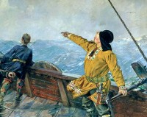 | 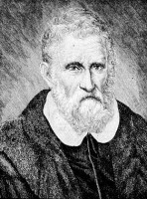 | 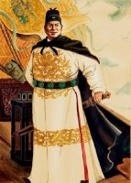
Leif Ericson (970-1020)  Nationality: Norwegian  Known For: Considered the first European to reach North America  Explorer Leif Ericson is considered to be the first European to arrive in North America and he did so almost 500 years before Christopher Columbus. He created a Norse settlement in Vinland which was located on the far north tip of Newfoundland in present day Canada. | Marco Polo (1254-1324)  Nationality: Venetian  Known For: Explored China and the Mongol Empire  Marco Polo was a merchant traveler who made notes on his travels in the book Livres des merveilles du monde. His journeys through Asia lasted over 24 years and it is said that his story later inspired Christopher Columbus and many others. | Zheng He (1371-1433)  Nationality: Chinese  Known For: Led expeditions to the Middle East, East Africa, South Asia and Southeast Asia  Zheng He was a great Chinese explorer, admiral, mariner and diplomat who led expeditions all across Asia, Africa and the Middle East. His connections and fame led him to become the leader of the southern capital Nanjing.
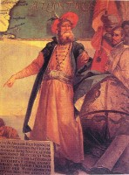 | 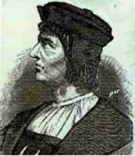 | 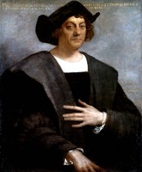
John Cabot (1450-1498)  Nationality: Italian  Known For: First European to visit North America since the time of the Vikings  John Cabot was the first European since the Norse Viking Leif Ericson to travel to North America. It is believed that he initially landed on Newfoundland in 1497. | Bartolomeu Dias (1451-1500)  Nationality: Portuguese  Known For: First European to sail around the southern tip of Africa  Bortolomeu Dias commanded the ship Sao Cristovao down the West coast of Africa and around the Cape of Good Hope. His discovery of this passage past the southern tip of Africa meant that Europeans would be able to trade with India directly without having to go through expensive middlemen in the Middle East. | Christopher Columbus (1451-1506)  Nationality: Italian  Known For: Made first trips that started the Spanish colonization of the Americas  Christopher Columbus made four total trips across the Atlantic Ocean which greatly helped to start and increase Spanish colonization in the “New World.” Columbus’ voyages led directly to an influx in European exploration throughout the world.
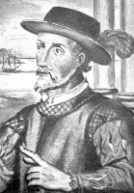 | 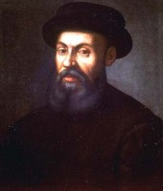 | 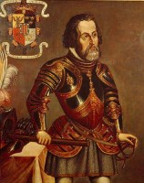
Juan Ponce de Leon (1474-1521)  Nationality: Spanish  Known For: Explored and named Florida  Juan Ponce de Leon was a famous conquistador and explorer. In his life he was the first Governor of Puerto Rico, he successfully explored and named Florida, and is closely tied to the notion of the Fountain of Youth being in Florida. | Ferdinand Magellan (1480-1521)  Nationality: Portuguese  Known For: First circumnavigation of the Earth  Ferdinand Magellan’s crew was the first to successfully circumnavigate the world. The expedition lasted from 1519 to 1522. Magellan himself did not survive the journey as he was killed in a battle in the Philippines. | Hernan Cortes (1485-1547)  Nationality: Spanish  Known For: Spanish conquest of the Aztec Empire  Hernan Cortes was an explorer and conquistador during the time when Spanish colonization of the Americas had just begun. The expedition that he led was essentially the main cause of the fall of the Aztec Empire. The result was that a large chunk of what is now Mexico fell under the power of the King of Castile.
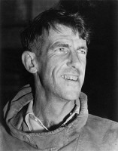 | 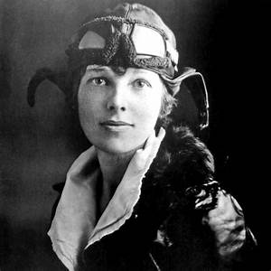 | 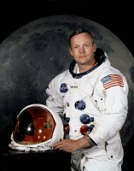
Edmund Hillary (1919-2008)  Nationality: New Zealander  Known For: First person to reach the top of Mount Everest  Sir Edmund Percival Hillary was a explorer and mountaineer. He, along with Nepalese Sherpa Tenzing Norgay, were the first to reach the summit of Mount Everest. Hillary was also the first person to get to both the North and South poles. | Amelia Earhart (1897-1937)  Nationality: American  Known For: The first woman to fly solo across the Atlantic Ocean, and the first person ever to fly solo from Hawaii to the U.S. mainland.  She set many flying records and championed the advancement of women in aviation. During a flight to circumnavigate the globe, Earhart disappeared somewhere over the Pacific in July 1937. Her plane wreckage was never found, and she was officially declared lost at sea. | Neil Armstrong (1930-2012)  Nationality: American  Known For: First person to walk on the Moon  Neil Armstrong was a pilot, aerospace engineer, professor and astronaut. He became the first person to walk on the moon on July 21st, 1969. His famous first words when he stepped out onto the moon were “That’s one small step for man, one giant leap for mankind.”

