World History II Assignment for week of 4/16

The unit we are covering is entitled “Science and Exploration”. We have covered in class (review Powerpoint Presentation) the science portion and are now going to look at Exploration.
- Read the rules for “Lost at Sea” and run the scenario. Score your results (don’t look at the answers until you are done. Normally, this is a group activity, so feel free to ask people in your home for advice on how to rate the objects. When you are done, score the sheet and email me your score. (msween@tuscola.k12.il.us) I will post the top 5 scores the following week.

- Read the notes on Exploration. (file attached and available at the website historyrockstchs.weebly.com) and answer the questions provided. If you have any questions about the material please see me during office hours (Google Meet 11-11:30 on Thursdays) or email me.

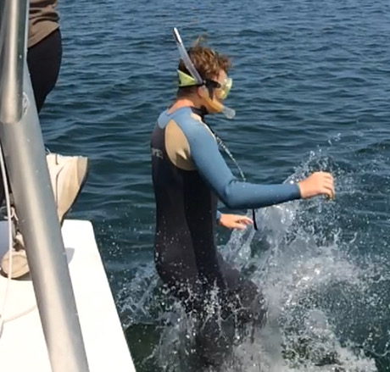
(Patrick doing some snorkeling in MI)

Lost At Sea Worksheet

Instructions

You are adrift on a private yacht in the South Pacific. As a consequence of a fire of unknown origin, much of the yacht and its contents have been destroyed. The yacht is slowly sinking. You location is unclear because of the destruction of critical navigational equipment and because you and the crew were distracted trying to bring the fire under control. You best estimate is that you are approximately one thousand miles south-southwest of the nearest land.

On the next page is a list of fifteen items that are intact and undamaged after the fire.
Your task is to rank the fifteen items below in terms of their importance to your survival. Place the number 1 by the most important item, the number 2 by second most important, and so on through number 15, the least important. Don’t peek at the answers until you have finished. Then score how you did. Send me your results.

__ Sextant
__ Shaving Mirror
__ Five-gallon can of water
__ Mosquito netting
__ One case of U.S. Army C- rations
__ Maps of the Pacific Ocean
__ Seat Cushion (flotation device approved by the Coast Guard)
__ Two-gallon can of oil-gas mixture
__ Small transistor radio
__ Shark repellent
__ Twenty square feet of opaque plastic
__ One quart of 160-proof Puerto Rican rum
__ Fifteen feet of nylon rope
__ Two boxes of chocolate bars
__ Fishing kit

After you have numbered your answers (1-15) with 1 being the most important item and 15 being the least important item, fill in the sheet and then fill in the sheet with the coast guard’s answers. After you are finished you simple take the difference between the numbers (last say you have a 5 for an item and the coastguard has a 10- the difference between the two items is 5). Lower numbers are better. There are no negative numbers, just the difference between the two.
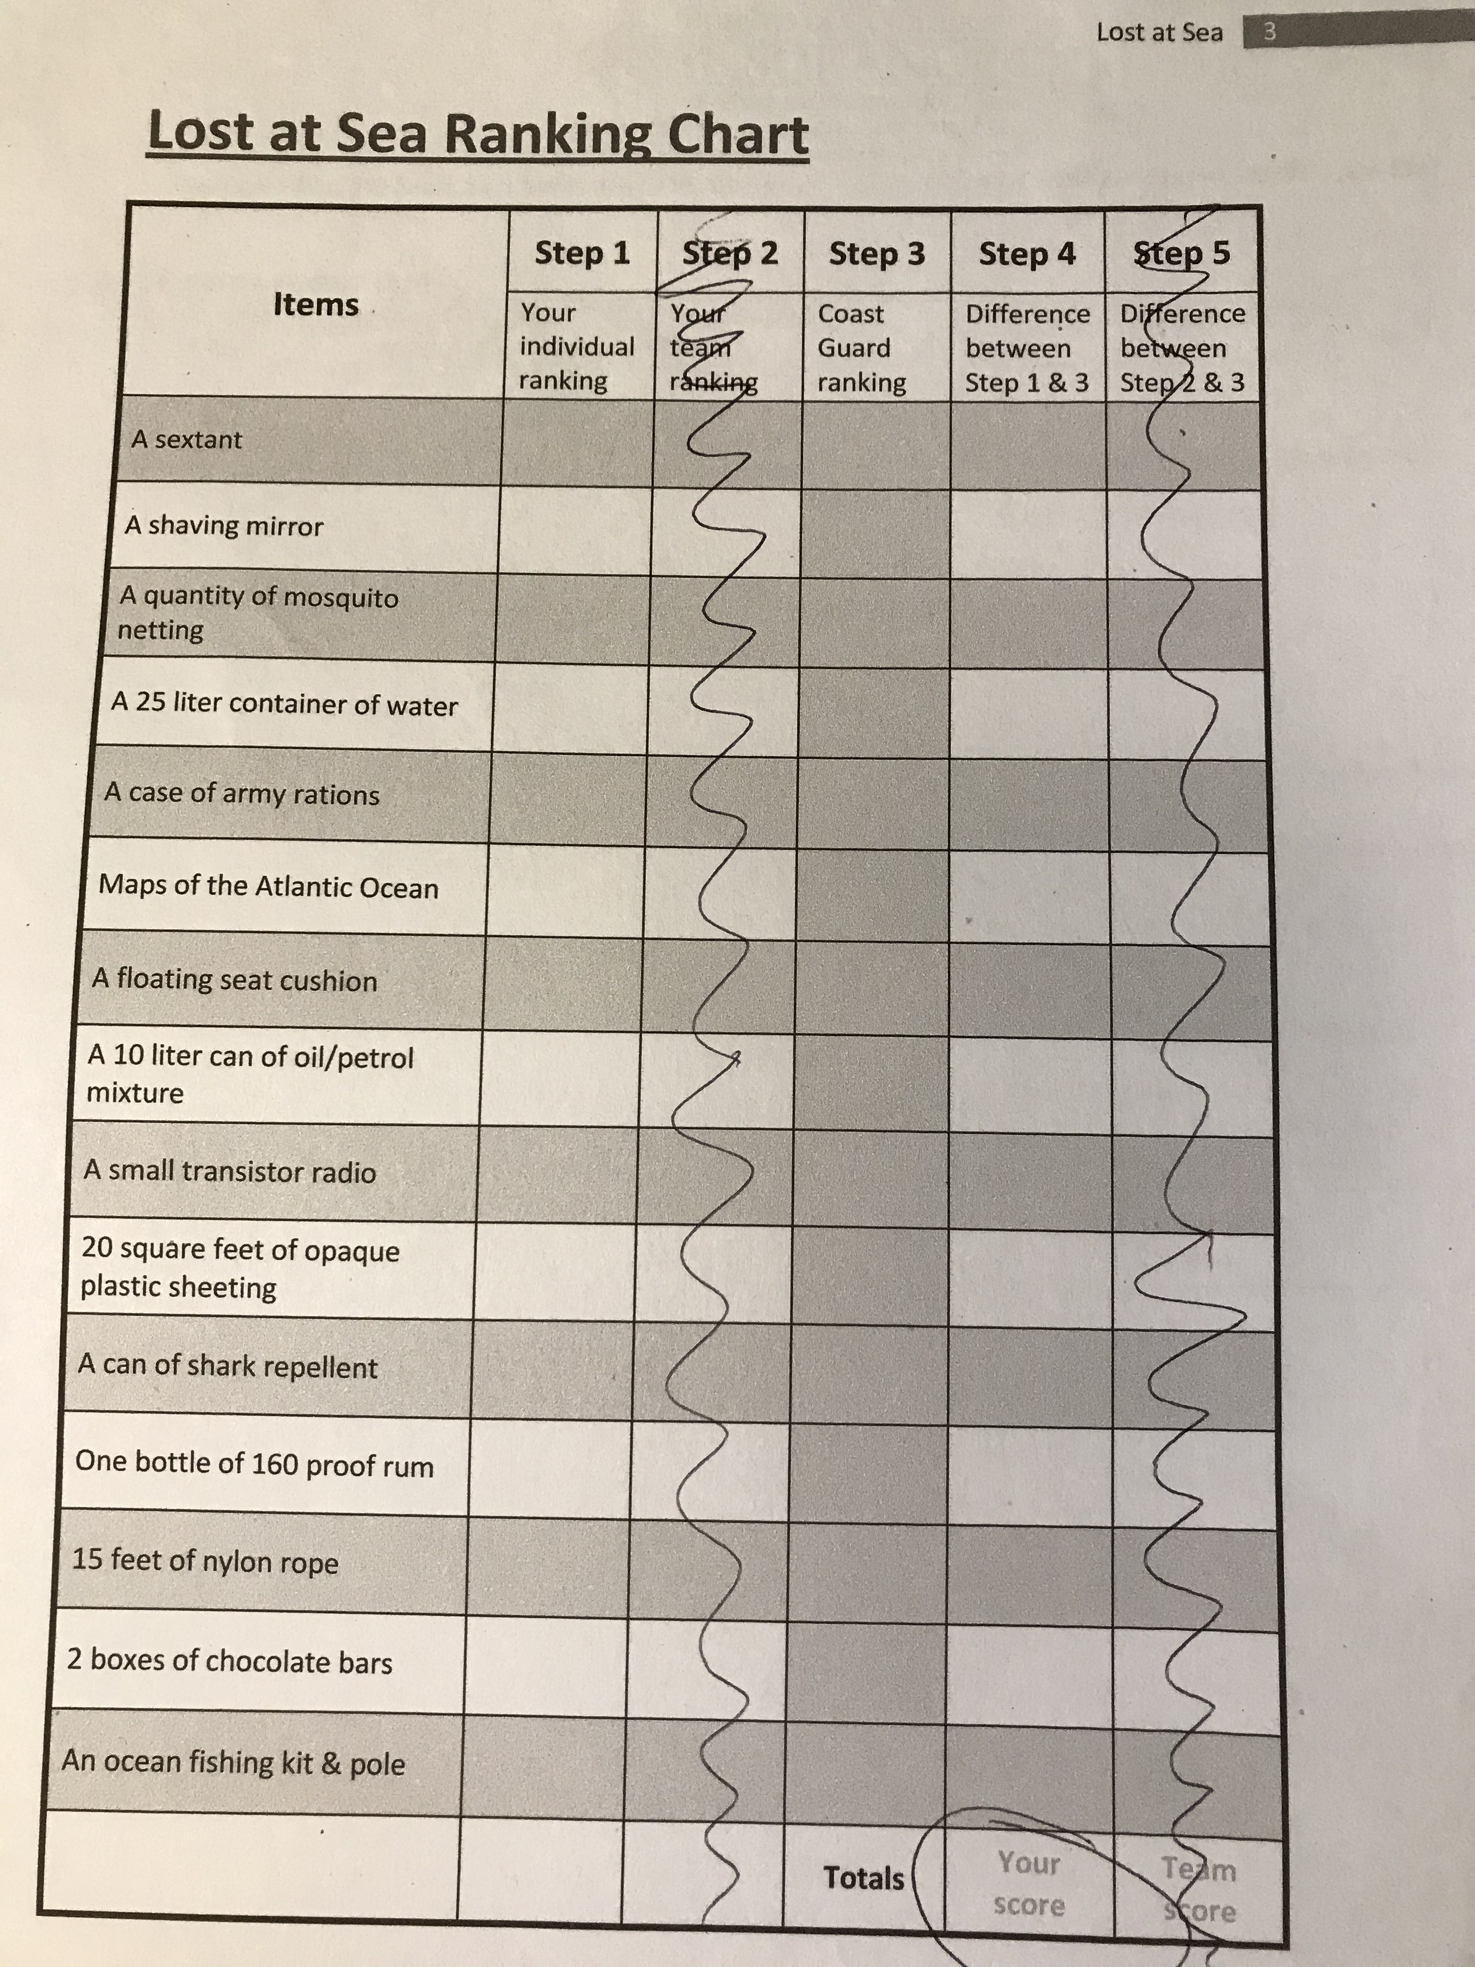

Calculating Scores

Using the answer sheet, the score is the difference between the actual answer and the individual/group ranking. Example:

Sextant Actual answer: 12 Individual/Group Ranking: 7 Score: 5

The lower the score the better. Calculate the score for each item and add them to find the total score. (These are the official answers as given by the U.S. Merchant Marines in their recruit training)

Answers

_12_ Sextant (No good without the chronometer)
_1 _ Shaving Mirror (Perfect for signaling passing aircraft)
_3 _ Five-gallon can of water (Can only survive app. 3 days without
water)
_14_ Mosquito netting (There are no mosquitoes that far out at
sea and moquito netting does not make a great fish net)
_4 _ One case of U.S. Army “C” rations (Better than nothing – you
have to eat)
_13 _ Maps of the Pacific Ocean ( You likely don’t know where you are so a map will only tell you where you aren’t)
_8 _ Seat Cushion (flotation device approved by the Coast Guard)
(Useful for saving people if they fall overboard)
_2 _ Two-gallon can of oil-gas mixture (Mixture will float on the
water and burn, good for signaling planes at night)
_15 _ Small transistor radio (Not a two-way radio, will not be able
to get a station that far out to sea)
_11 _ Shark repellent (Self explanatory)
_6 _ Twenty square feet of opaque plastic (Good for covering up and
keeping warm, also good for collecting water –
condensation)
_10_ One quart of 160-proof Puerto Rican rum (Alcohol makes you
dehyrdrate – DO NOT DRINK – use for cleaning wounds
etc.)
_9 _ Fifteen feet of nylon rope (Rope is always good)
_5 _ Two boxes of chocolate bars (Good energy source if desperate)
_7 _ Fishing kit (The fish are likely quite deep but the contents
are very handy)

