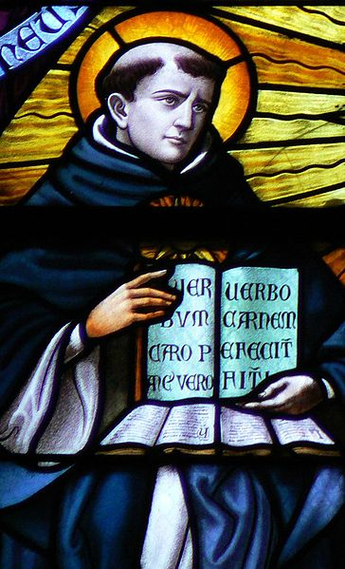

Summa Theologica: Structure, Scope, and Purpose

Summary
The Summa Theologica is divided into three parts, and each of these three parts contains numerous subdivisions. Part 1 deals primarily with God and comprises discussions of 119 questions concerning the existence and nature of God, the Creation, angels, the work of the six days of Creation, the essence and nature of man, and divine government. Part 2 deals with man and includes discussions of 303 questions concerning the purpose of man, habits, types of law, vices and virtues, prudence and justice, fortitude and temperance, graces, and the religious versus the secular life. Part 3 deals with Christ and comprises discussions of 90 questions concerning the Incarnation, the Sacraments, and the Resurrection. Some editions of the Summa Theologica include a Supplement comprising discussions of an additional 99 questions concerning a wide variety of loosely related issues such as excommunication, indulgences, confession, marriage, purgatory, and the relations of the saints toward the damned. Scholars believe that Rainaldo da Piperno, a friend of Aquinas, probably gathered the material in this supplement from a work that Aquinas had completed before he began working on the Summa Theologica.
The Summa Theologica, as its title indicates, is a “theological summary.” It seeks to describe the relationship between God and man and to explain how man’s reconciliation with the Divine is made possible at all through Christ. To this end, Aquinas cites proofs for the existence of God and outlines the activities and nature of God. Approximately one-half of the Summa Theologica then examines the nature and purpose of man. Finally, Aquinas devotes his attention to the nature of Christ and the role of the Sacraments in effecting a bridge between God and man. Within these broad topical boundaries, though, Aquinas examines the nature of God and man in exquisite detail. His examination includes questions of how angels act on bodies, the union of body and soul, the cause and remedies of anger, cursing, and the comparison of one sin with another. Aquinas is attempting to offer a truly universal and rational view of all existence.

Analysis
Adopting Aristotelian principles and concepts, Aquinas attempts to explain the origin, operation, and purpose of the entire universe and the role that everything in the universe plays in the attainment of that purpose. Aquinas never doubts the truth of the tenets of his faith. Rather, he employs techniques of argument that he learned in the disputatios to state, defend, and elaborate those tenets. The grandiose scope of the Summa Theologica derives from Aquinas’s belief that a very significant portion of theology can be expressed and codified in a comprehensive and rational system.
Aquinas writes not only as a philosopher who is intellectually interested in the pursuit of truth, he writes primarily as a Catholic who is convinced that the salvation of humanity itself is at stake. This conviction propels him toward a rational exegesis of topics the truth of which is ultimately derived and founded on divine revelation. When a specific topic so allows, Aquinas uses philosophical concepts and vocabulary to examine that topic. The primary topics admitting of such philosophical examination are the existence of God, the nature and limits of human knowledge, and the purpose of man. For most other topics, Aquinas articulates a decidedly Catholic position on issues of Christian interest, such as the Holy Trinity, original sin, and the like.
At first glance, it would seem astonishing and even counterintuitive that Aquinas reframes much of Catholic theology in terms of Aristotle’s pre-Christian philosophy. The pursuit of philosophy traditionally requires one to enter into debates with an open mind and to identify and re-examine one’s own core assumptions about a given issue, yet Aquinas enlists Aristotle not for his aid in the unbiased critical examination of the tenets of Catholic belief but rather for the explication and defense of those tenets. At the same time, though, Aquinas’s enlistment of Aristotle reveals Aquinas to be a remarkably fair, open minded, and indeed tolerant medieval thinker. He apparently believes that the fruits of the exercise of reason are not necessarily corrupt if the thinker is a non-Christian. This suggests that Aquinas believes that every human being, regardless of his or her beliefs, shares in humanity through the possession and use of reason. In this, Aquinas again reveals his indebtedness and allegiance to Aristotle, who had maintained that reason is the essential quality of humanity: it is that without which man cannot be man.

