The Amazing Diversity and History of Egyptian Hieroglyphics
Rutuja Jathar

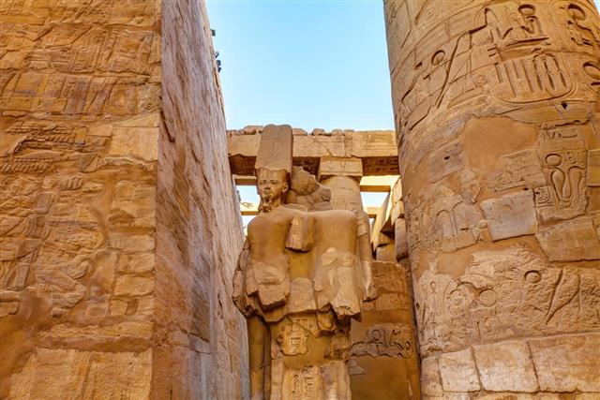
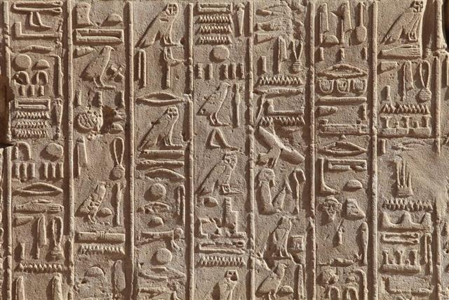
Egyptian language has the longest history of all the languages of the world. The Egyptian started this formal writing system called hieroglyphs, around 4000 years ago. There are more than 700 individual symbols to it. Many refer to hieroglyphs as the ancient language of the country, but it is merely a form of a script in the language. This scripting was in pictorial form. They used various signs instead of letters and words, and this is the most fascinating feature of their language. One more interesting fact about the symbols, is that a single symbol had more than three different meanings, which could either be phonetic or simply symbolizing the picture itself. They continued using it until around 500 AD, and the language is still the most difficult language to learn. It is said that there were thousands of signs that were used, and many of them were not even used initially. To learn more about the history of Egyptian hieroglyphics, read the paragraphs below.
Origin
We can call hieroglyphs as the 'sacred picture writing', as the word is combination of two Egyptian words hieros meaning 'holy', and glyphe meaning 'carving'. The carvings were called sacred, because they were made by the priests and only at selective places, such as temples, tombs, public buildings, and monuments. Only priests had the right to learn and write the Hieroglyphs. Hieroglyphics emerged from the artistic tradition and the preliterate cultural background of ancient Egypt. They called their script as 'mdju netjer', which means 'words of gods'. The Thoth (the ibis-headed Egyptian god) was believed to be the patron of writing. There are five phases of this ancient language namely - Old Egyptian, classical Egyptian (Main Egyptian), late Egyptian, demotic, and coptic. During the course of 3500 years of the usage of the Hieroglyphs, the language underwent many changes, and the number of signs also increased to/by around about a thousand.
Egyptians wrote cursive Hieroglyphs on papyri or wood. The language didn't show any dialect till the Coptic phase. There were some regional dialects, around Thebes and Memphis. There were a few forms of writing the language:
Hieroglyphics
This form of writing was found on papyri and on some monuments. This was nothing but pictures that symbolized some words. It started with symbols for each word, and then, the symbols were blended together, to form a word. This was the oldest of the scripts that changed with the passing time.
Hieratic
This could be referred to as the script hieroglyphics. It has changed gradually within the phases of the ancient language. Hieratic was a quicker and easier form. This was the official script used for the business and administrative purposes for recording historic documents and the documents of scientific and religious nature. It was scripted on the stone ostraca, papyri roles, sheets, and on pottery.
Demotic
Demotic means 'popular script' or 'the people's writing'. Demotic was the only generalized script present during the Hellenistic period of the Ptolemies. Derived directly from the Hieratic, it was very cursive script. That made this script very difficult to read and even more difficult to translate. It was used to write legal and commercial matters.
Coptic
This is the modified version of the demotic and was in use during the first century AD. The ancient script was basically of two types, namely - phonetics and determinative. Most words were made using Phonetic signs, followed by a determinative. Some words had more than two determinatives, and the most common words had no determinatives at all. Certain hieroglyphs were arranged either in horizontal lines or in columns. It was read from the left to the right and from the upper to the lower in case of columns. The hieroglyphs had no punctuation marks, diversion marks or spaces in between the words.
Following are the Hieroglyphic signs:
- Alphabets: The alphabetic signs were used in only some of the common words. These were signs that described the objects.
- Determinatives: These signs had no sound but gave the exact clues about the meaning of the word. Most words ended by the determinatives, though some had no determinatives at all.
- Abbreviations: If one or two words represented an entire word or a phrase, an abbreviation was the most common thing used.
- Ideograms: An ideogram means a special kind of abbreviation. Ideograms were occasionally present along with a phonetic sign followed by a vertical line. The line represented the appearance of the actual object, in more or less definite terms.
- Other phonetic signs: Many words, at any stage of the word formation, began with a phonetic sign but were not alphabetic. Mostly, they stood for two or more alphabetic signs, that helped to understand the sound of the entire word.
The first hieroglyphs were discovered during the excavations near Kawm al-Ahmar (ancient Hierakonpolis), on the pottery objects best known as the 'Narmer Palette' dated around 3200 BC. The last hieroglyphs were found in a temple, on the Phylae Island in the year 394 AD. After the development of the hieratic, hieroglyphics remained only for religious and monumental usage.
The hieroglyphics were hard to understand for ages, till the discovery of the mysterious Rosetta Stone. It was discovered in Rosetta, at the time of Napoleon's failed attempt to invade Egypt. It contains the demotic, Greek as well as the hieroglyphic scripts on it. This stone really turned to a milestone for the linguists all around the world. Jean-Francois Champollion is credited as the decoder of the hieroglyphics. They are, and can be transliterated today also. The excavations of tombs proved that they were used to write the royalty nameplates called 'cartouche' and on jewelry also.
The Egyptian hieroglyphics proved to be the strongest medium to unravel the mystery of the culture, its accomplishments, its discoveries and the history of the ancient Egypt.
