Archaeologists who made the macabre find believe all were killed by the Plague which wiped out 1.5million Britons in 1348
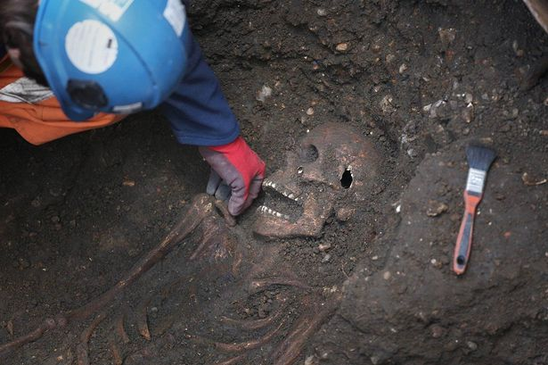Grisly find: A skeleton is examined
PA
A mass grave believed to be full of Black Death victims has been unearthed during digging work on a £14.8billion new railway.
So far 13 adult skeletons have been found in a London square being excavated as part of the Crossrail project.
Archaeologists who made the macabre find believe all were killed by the Plague which wiped out 1.5million Britons in 1348.
Pottery found in the graves dates to 1350 and the layout of the skeletons all point to them being plague victims.
Spokesman Nick Elseden said tests would be carried out on the bodies but added there was no health risk.
“It’s not something that stays in the soil,” he said. “You have to meet someone who has it to catch it.”
Crossrail lead archaeologist Jay Carver said the discovery in Charterhouse Square, Farringdon, could help medical research.
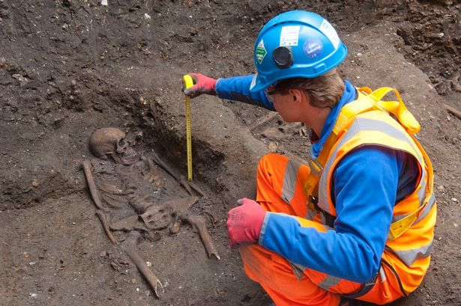Extraction: Skeleton thought to be from a 14th century burial ground
PA

“Scientists hope to map the plague virus DNA. Biologists are researching ancient diseases in the hope of better understanding modern ones,” said Mr Carver.
These are not the first skeletons found on the Crossrail projects, with archaeologists already uncovering more than 300 at a known burial ground at Liverpool Street in London that dates from the 1500s to 1700s.
That burial ground was located near the Bedlam Hospital.
Archaeologists also hope to find Roman artefacts as they dig deeper at the Farringdon site.
A similar skeleton formation was found in a Black Death burial site in nearby east Smithfield in the 1980s.
The skeletons are being carefully excavated and taken to the Museum of London Archaeology for testing.
Once analysis has been completed, the skeletons will be reburied on the site or at another cemetery.

