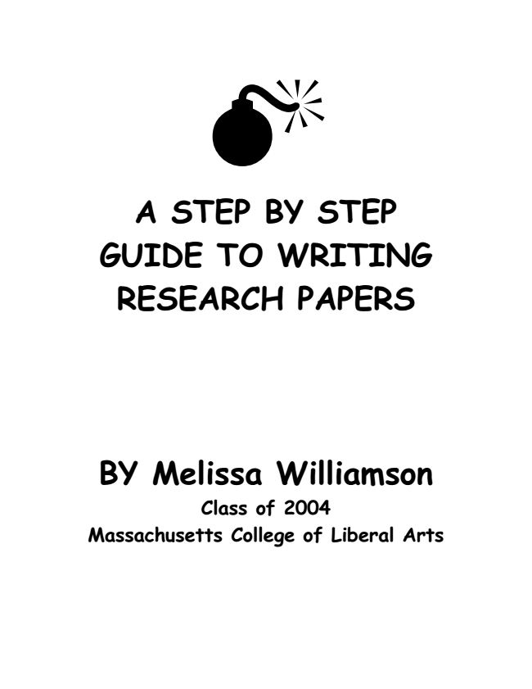
A STEP BY STEP GUIDE TO WRITING RESEARCH PAPERS
BY Melissa Williamson Class of 2004 Massachusetts College of Liberal Arts

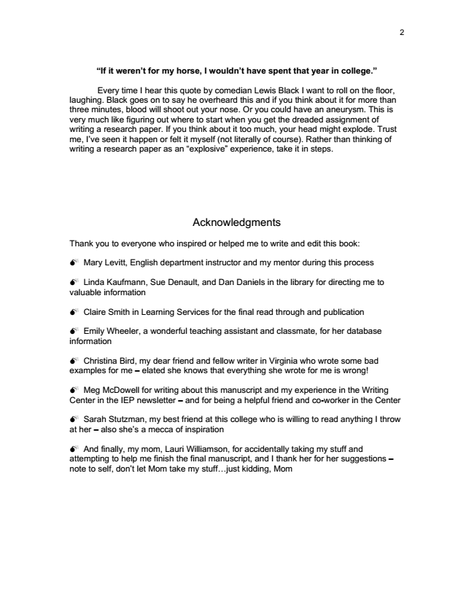
2
“If it weren’t for my horse, I wouldn’t have spent that year in college.”
Every time I hear this quote by comedian Lewis Black I want to roll on the floor, laughing. Black goes on to say he overheard this and if you think about it for more than three minutes, blood will shoot out your nose. Or you could have an aneurysm. This is very much like figuring out where to start when you get the dreaded assignment of writing a research paper. If you think about it too much, your head might explode. Trust me, I’ve seen it happen or felt it myself (not literally of course). Rather than thinking of writing a research paper as an “explosive” experience, take it in steps.
Acknowledgments
Thank you to everyone who inspired or helped me to write and edit this book:
Mary Levitt, English department instructor and my mentor during this process
Linda Kaufmann, Sue Denault, and Dan Daniels in the library for directing me to valuable information
Claire Smith in Learning Services for the final read through and publication
Emily Wheeler, a wonderful teaching assistant and classmate, for her database information
Christina Bird, my dear friend and fellow writer in Virginia who wrote some bad examples for me – elated she knows that everything she wrote for me is wrong!
Meg McDowell for writing about this manuscript and my experience in the Writing Center in the IEP newsletter – and for being a helpful friend and co-worker in the Center
Sarah Stutzman, my best friend at this college who is willing to read anything I throw at her – also she’s a mecca of inspiration
And finally, my mom, Lauri Williamson, for accidentally taking my stuff and attempting to help me finish the final manuscript, and I thank her for her suggestions – note to self, don’t let Mom take my stuff...just kidding, Mom

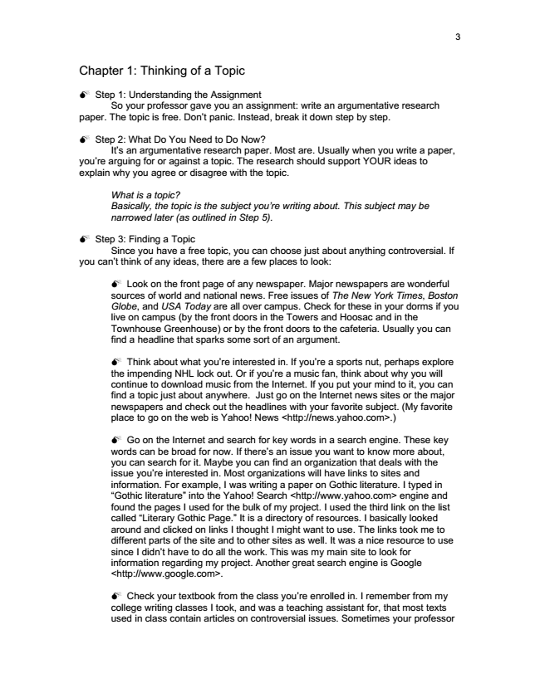
3
Chapter 1: Thinking of a Topic
Step 1: Understanding the Assignment
So your professor gave you an assignment: write an argumentative research paper. The topic is free. Don’t panic. Instead, break it down step by step.
Step 2: What Do You Need to Do Now?
It’s an argumentative research paper. Most are. Usually when you write a paper, you’re arguing for or against a topic. The research should support YOUR ideas to explain why you agree or disagree with the topic.
What is a topic? Basically, the topic is the subject you’re writing about. This subject may be narrowed later (as outlined in Step 5).
Step 3: Finding a Topic
Since you have a free topic, you can choose just about anything controversial. If you can’t think of any ideas, there are a few places to look:
Look on the front page of any newspaper. Major newspapers are wonderful sources of world and national news. Free issues of The New York Times, Boston Globe, and USA Today are all over campus. Check for these in your dorms if you live on campus (by the front doors in the Towers and Hoosac and in the Townhouse Greenhouse) or by the front doors to the cafeteria. Usually you can find a headline that sparks some sort of an argument.
Think about what you’re interested in. If you’re a sports nut, perhaps explore the impending NHL lock out. Or if you’re a music fan, think about why you will continue to download music from the Internet. If you put your mind to it, you can find a topic just about anywhere. Just go on the Internet news sites or the major newspapers and check out the headlines with your favorite subject. (My favorite place to go on the web is Yahoo! News <http://news.yahoo.com>.)
Go on the Internet and search for key words in a search engine. These key words can be broad for now. If there’s an issue you want to know more about, you can search for it. Maybe you can find an organization that deals with the issue you’re interested in. Most organizations will have links to sites and information. For example, I was writing a paper on Gothic literature. I typed in “Gothic literature” into the Yahoo! Search <http://www.yahoo.com> engine and found the pages I used for the bulk of my project. I used the third link on the list called “Literary Gothic Page.” It is a directory of resources. I basically looked around and clicked on links I thought I might want to use. The links took me to different parts of the site and to other sites as well. It was a nice resource to use since I didn’t have to do all the work. This was my main site to look for information regarding my project. Another great search engine is Google <http://www.google.com>.
Check your textbook from the class you’re enrolled in. I remember from my college writing classes I took, and was a teaching assistant for, that most texts used in class contain articles on controversial issues. Sometimes your professor

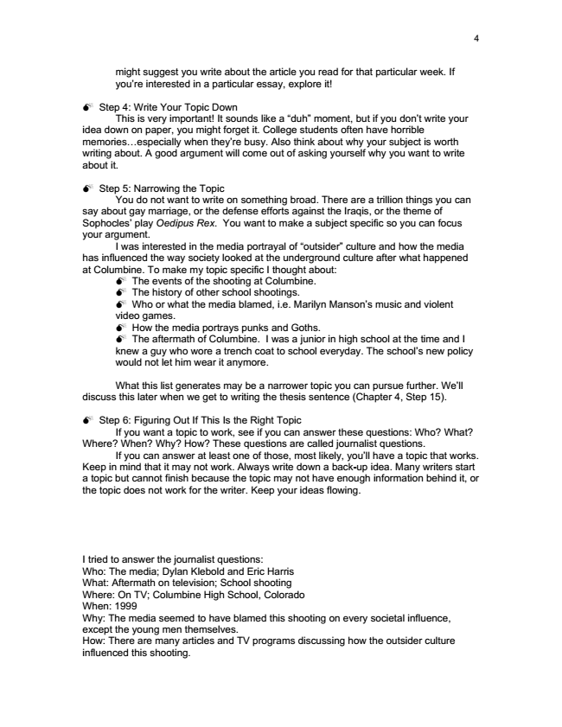
4
might suggest you write about the article you read for that particular week. If you’re interested in a particular essay, explore it!
Step 4: Write Your Topic Down
This is very important! It sounds like a “duh” moment, but if you don’t write your idea down on paper, you might forget it. College students often have horrible memories...especially when they’re busy. Also think about why your subject is worth writing about. A good argument will come out of asking yourself why you want to write about it.
Step 5: Narrowing the Topic
You do not want to write on something broad. There are a trillion things you can say about gay marriage, or the defense efforts against the Iraqis, or the theme of Sophocles’ play Oedipus Rex. You want to make a subject specific so you can focus your argument.
I was interested in the media portrayal of “outsider” culture and how the media has influenced the way society looked at the underground culture after what happened at Columbine. To make my topic specific I thought about:
The events of the shooting at Columbine. The history of other school shootings. Who or what the media blamed, i.e. Marilyn Manson’s music and violent video games.
How the media portrays punks and Goths. The aftermath of Columbine. I was a junior in high school at the time and I knew a guy who wore a trench coat to school everyday. The school’s new policy would not let him wear it anymore.
What this list generates may be a narrower topic you can pursue further. We’ll discuss this later when we get to writing the thesis sentence (Chapter 4, Step 15).
Step 6: Figuring Out If This Is the Right Topic
If you want a topic to work, see if you can answer these questions: Who? What? Where? When? Why? How? These questions are called journalist questions.
If you can answer at least one of those, most likely, you’ll have a topic that works. Keep in mind that it may not work. Always write down a back-up idea. Many writers start a topic but cannot finish because the topic may not have enough information behind it, or the topic does not work for the writer. Keep your ideas flowing.
I tried to answer the journalist questions: Who: The media; Dylan Klebold and Eric Harris What: Aftermath on television; School shooting Where: On TV; Columbine High School, Colorado When: 1999 Why: The media seemed to have blamed this shooting on every societal influence, except the young men themselves. How: There are many articles and TV programs discussing how the outsider culture influenced this shooting.

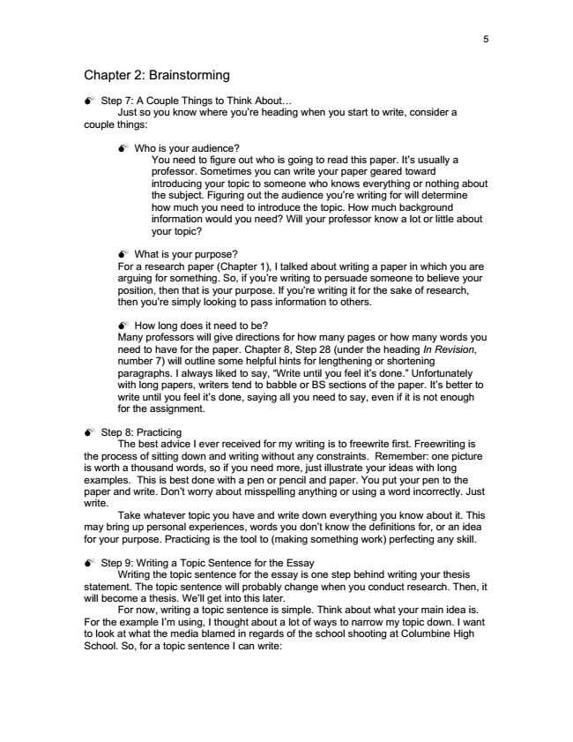
5
Chapter 2: Brainstorming
Step 7: A Couple Things to Think About...
Just so you know where you’re heading when you start to write, consider a couple things:
Who is your audience?
You need to figure out who is going to read this paper. It’s usually a professor. Sometimes you can write your paper geared toward introducing your topic to someone who knows everything or nothing about the subject. Figuring out the audience you’re writing for will determine how much you need to introduce the topic. How much background information would you need? Will your professor know a lot or little about your topic?
What is your purpose? For a research paper (Chapter 1), I talked about writing a paper in which you are arguing for something. So, if you’re writing to persuade someone to believe your position, then that is your purpose. If you’re writing it for the sake of research, then you’re simply looking to pass information to others.
How long does it need to be? Many professors will give directions for how many pages or how many words you need to have for the paper. Chapter 8, Step 28 (under the heading In Revision, number 7) will outline some helpful hints for lengthening or shortening paragraphs. I always liked to say, “Write until you feel it’s done.” Unfortunately with long papers, writers tend to babble or BS sections of the paper. It’s better to write until you feel it’s done, saying all you need to say, even if it is not enough for the assignment.
Step 8: Practicing
The best advice I ever received for my writing is to freewrite first. Freewriting is the process of sitting down and writing without any constraints. Remember: one picture is worth a thousand words, so if you need more, just illustrate your ideas with long examples. This is best done with a pen or pencil and paper. You put your pen to the paper and write. Don’t worry about misspelling anything or using a word incorrectly. Just write.
Take whatever topic you have and write down everything you know about it. This may bring up personal experiences, words you don’t know the definitions for, or an idea for your purpose. Practicing is the tool to (making something work) perfecting any skill.
Step 9: Writing a Topic Sentence for the Essay
Writing the topic sentence for the essay is one step behind writing your thesis statement. The topic sentence will probably change when you conduct research. Then, it will become a thesis. We’ll get into this later.
For now, writing a topic sentence is simple. Think about what your main idea is. For the example I’m using, I thought about a lot of ways to narrow my topic down. I want to look at what the media blamed in regards of the school shooting at Columbine High School. So, for a topic sentence I can write:

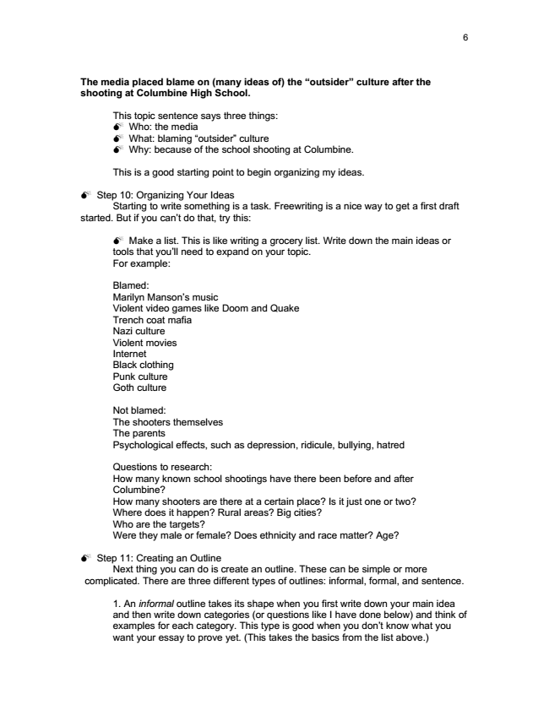
6
The media placed blame on (many ideas of) the “outsider” culture after the shooting at Columbine High School.
This topic sentence says three things:
Who: the media What: blaming “outsider” culture Why: because of the school shooting at Columbine.
This is a good starting point to begin organizing my ideas.
Step 10: Organizing Your Ideas
Starting to write something is a task. Freewriting is a nice way to get a first draft started. But if you can’t do that, try this:
Make a list. This is like writing a grocery list. Write down the main ideas or tools that you’ll need to expand on your topic. For example:
Blamed: Marilyn Manson’s music Violent video games like Doom and Quake Trench coat mafia Nazi culture Violent movies Internet Black clothing Punk culture Goth culture
Not blamed: The shooters themselves The parents Psychological effects, such as depression, ridicule, bullying, hatred
Questions to research: How many known school shootings have there been before and after Columbine? How many shooters are there at a certain place? Is it just one or two? Where does it happen? Rural areas? Big cities? Who are the targets? Were they male or female? Does ethnicity and race matter? Age?
Step 11: Creating an Outline
Next thing you can do is create an outline. These can be simple or more complicated. There are three different types of outlines: informal, formal, and sentence.
1. An informal outline takes its shape when you first write down your main idea and then write down categories (or questions like I have done below) and think of examples for each category. This type is good when you don’t know what you want your essay to prove yet. (This takes the basics from the list above.)

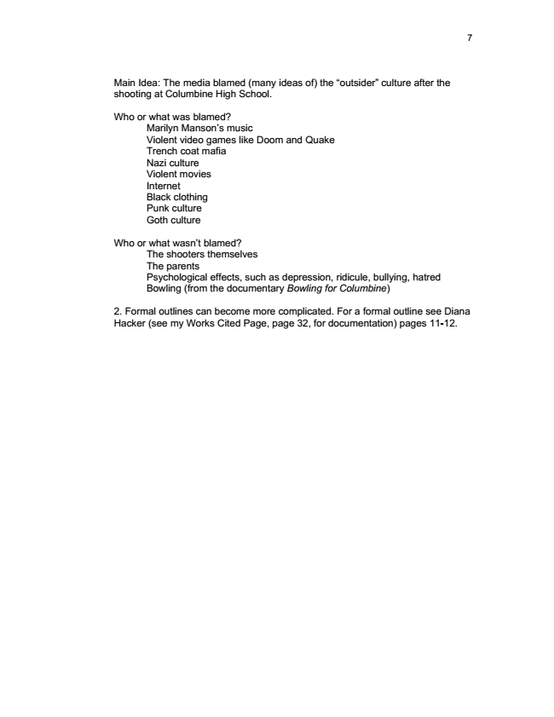
7
Main Idea: The media blamed (many ideas of) the “outsider” culture after the shooting at Columbine High School.
Who or what was blamed?
Marilyn Manson’s music Violent video games like Doom and Quake Trench coat mafia Nazi culture Violent movies Internet Black clothing Punk culture Goth culture
Who or what wasn’t blamed?
The shooters themselves The parents Psychological effects, such as depression, ridicule, bullying, hatred Bowling (from the documentary Bowling for Columbine)
2. Formal outlines can become more complicated. For a formal outline see Diana Hacker (see my Works Cited Page, page 32, for documentation) pages 11-12.

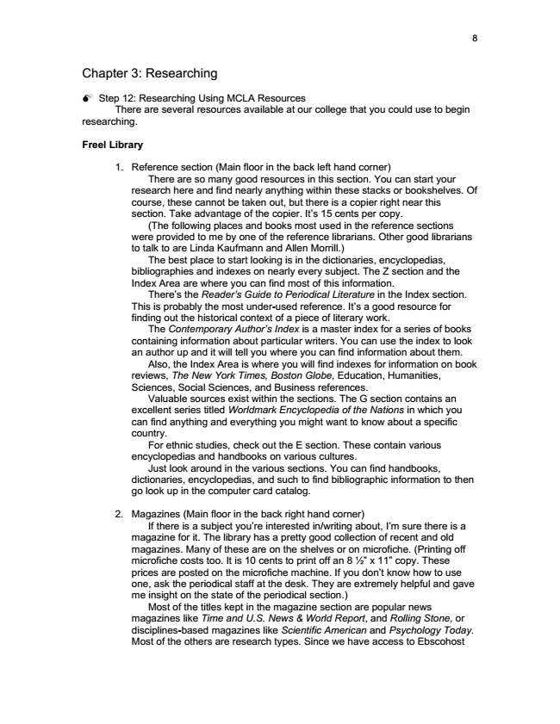
8
Chapter 3: Researching
Step 12: Researching Using MCLA Resources
There are several resources available at our college that you could use to begin researching.
Freel Library
1. Reference section (Main floor in the back left hand corner)
There are so many good resources in this section. You can start your research here and find nearly anything within these stacks or bookshelves. Of course, these cannot be taken out, but there is a copier right near this section. Take advantage of the copier. It’s 15 cents per copy.
(The following places and books most used in the reference sections were provided to me by one of the reference librarians. Other good librarians to talk to are Linda Kaufmann and Allen Morrill.)
The best place to start looking is in the dictionaries, encyclopedias, bibliographies and indexes on nearly every subject. The Z section and the Index Area are where you can find most of this information.
There’s the Reader’s Guide to Periodical Literature in the Index section. This is probably the most under-used reference. It’s a good resource for finding out the historical context of a piece of literary work.
The Contemporary Author’s Index is a master index for a series of books containing information about particular writers. You can use the index to look an author up and it will tell you where you can find information about them.
Also, the Index Area is where you will find indexes for information on book reviews, The New York Times, Boston Globe, Education, Humanities, Sciences, Social Sciences, and Business references.
Valuable sources exist within the sections. The G section contains an excellent series titled Worldmark Encyclopedia of the Nations in which you can find anything and everything you might want to know about a specific country.
For ethnic studies, check out the E section. These contain various encyclopedias and handbooks on various cultures.
Just look around in the various sections. You can find handbooks, dictionaries, encyclopedias, and such to find bibliographic information to then go look up in the computer card catalog.
2. Magazines (Main floor in the back right hand corner)
If there is a subject you’re interested in/writing about, I’m sure there is a magazine for it. The library has a pretty good collection of recent and old magazines. Many of these are on the shelves or on microfiche. (Printing off microfiche costs too. It is 10 cents to print off an 8 1⁄2” x 11” copy. These prices are posted on the microfiche machine. If you don’t know how to use one, ask the periodical staff at the desk. They are extremely helpful and gave me insight on the state of the periodical section.)
Most of the titles kept in the magazine section are popular news magazines like Time and U.S. News & World Report, and Rolling Stone, or disciplines-based magazines like Scientific American and Psychology Today. Most of the others are research types. Since we have access to Ebscohost

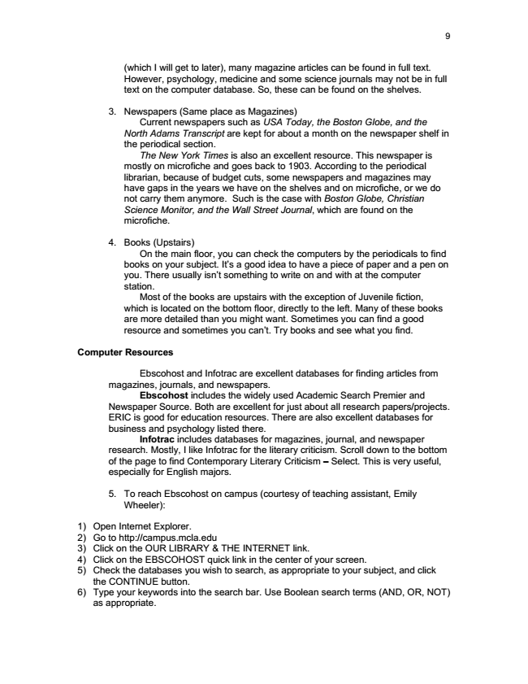
9
(which I will get to later), many magazine articles can be found in full text. However, psychology, medicine and some science journals may not be in full text on the computer database. So, these can be found on the shelves.
3. Newspapers (Same place as Magazines)
Current newspapers such as USA Today, the Boston Globe, and the North Adams Transcript are kept for about a month on the newspaper shelf in the periodical section.
The New York Times is also an excellent resource. This newspaper is mostly on microfiche and goes back to 1903. According to the periodical librarian, because of budget cuts, some newspapers and magazines may have gaps in the years we have on the shelves and on microfiche, or we do not carry them anymore. Such is the case with Boston Globe, Christian Science Monitor, and the Wall Street Journal, which are found on the microfiche.
4. Books (Upstairs)
On the main floor, you can check the computers by the periodicals to find books on your subject. It’s a good idea to have a piece of paper and a pen on you. There usually isn’t something to write on and with at the computer station.
Most of the books are upstairs with the exception of Juvenile fiction, which is located on the bottom floor, directly to the left. Many of these books are more detailed than you might want. Sometimes you can find a good resource and sometimes you can’t. Try books and see what you find.
Computer Resources
Ebscohost and Infotrac are excellent databases for finding articles from magazines, journals, and newspapers.
Ebscohost includes the widely used Academic Search Premier and Newspaper Source. Both are excellent for just about all research papers/projects. ERIC is good for education resources. There are also excellent databases for business and psychology listed there.
Infotrac includes databases for magazines, journal, and newspaper research. Mostly, I like Infotrac for the literary criticism. Scroll down to the bottom of the page to find Contemporary Literary Criticism – Select. This is very useful, especially for English majors.
5. To reach Ebscohost on campus (courtesy of teaching assistant, Emily
Wheeler):
1) Open Internet Explorer. 2) Go to http://campus.mcla.edu 3) Click on the OUR LIBRARY & THE INTERNET link. 4) Click on the EBSCOHOST quick link in the center of your screen. 5) Check the databases you wish to search, as appropriate to your subject, and click
the CONTINUE button. 6) Type your keywords into the search bar. Use Boolean search terms (AND, OR, NOT)
as appropriate.

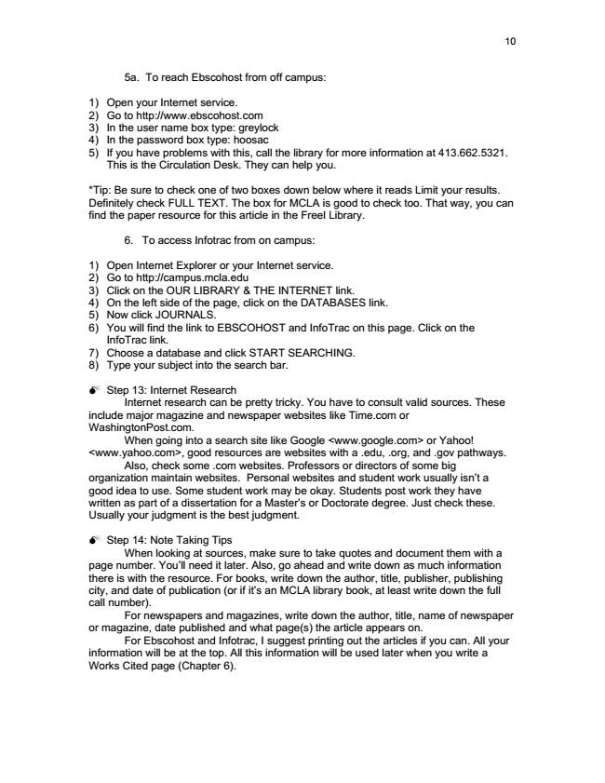
10
5a. To reach Ebscohost from off campus:
1) Open your Internet service. 2) Go to http://www.ebscohost.com 3) In the user name box type: greylock 4) In the password box type: hoosac 5) If you have problems with this, call the library for more information at 413.662.5321.
This is the Circulation Desk. They can help you.
*Tip: Be sure to check one of two boxes down below where it reads Limit your results. Definitely check FULL TEXT. The box for MCLA is good to check too. That way, you can find the paper resource for this article in the Freel Library.
6. To access Infotrac from on campus:
1) Open Internet Explorer or your Internet service. 2) Go to http://campus.mcla.edu 3) Click on the OUR LIBRARY & THE INTERNET link. 4) On the left side of the page, click on the DATABASES link. 5) Now click JOURNALS. 6) You will find the link to EBSCOHOST and InfoTrac on this page. Click on the
InfoTrac link. 7) Choose a database and click START SEARCHING. 8) Type your subject into the search bar.
Step 13: Internet Research
Internet research can be pretty tricky. You have to consult valid sources. These include major magazine and newspaper websites like Time.com or WashingtonPost.com.
When going into a search site like Google <www.google.com> or Yahoo! <www.yahoo.com>, good resources are websites with a .edu, .org, and .gov pathways.
Also, check some .com websites. Professors or directors of some big organization maintain websites. Personal websites and student work usually isn’t a good idea to use. Some student work may be okay. Students post work they have written as part of a dissertation for a Master’s or Doctorate degree. Just check these. Usually your judgment is the best judgment.
Step 14: Note Taking Tips
When looking at sources, make sure to take quotes and document them with a page number. You’ll need it later. Also, go ahead and write down as much information there is with the resource. For books, write down the author, title, publisher, publishing city, and date of publication (or if it’s an MCLA library book, at least write down the full call number).
For newspapers and magazines, write down the author, title, name of newspaper or magazine, date published and what page(s) the article appears on.
For Ebscohost and Infotrac, I suggest printing out the articles if you can. All your information will be at the top. All this information will be used later when you write a Works Cited page (Chapter 6).

